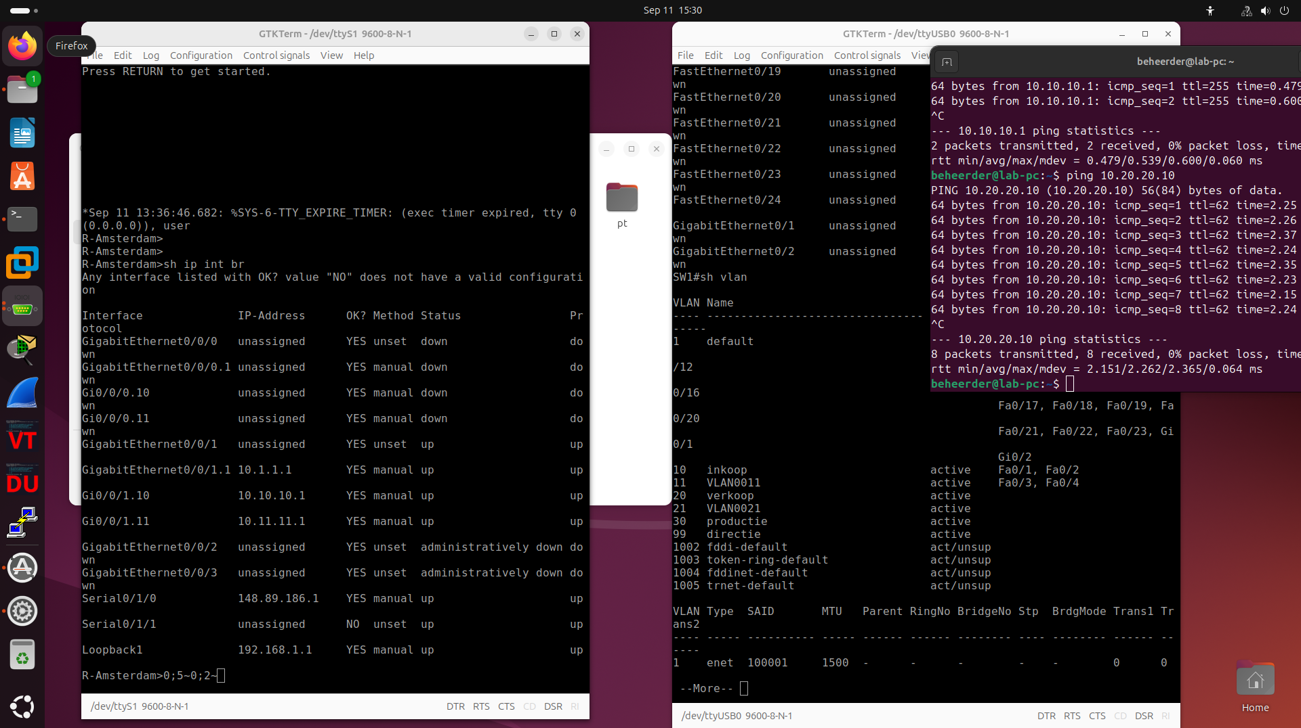
-Amsterdam#sh run
Building configuration...

Current configuration : 6955 bytes
!
! Last configuration change at 13:18:14 UTC Fri Sep 11 2026
!
version 17.6
service timestamps debug datetime msec
service timestamps log datetime msec
! Call-home is enabled by Smart-Licensing.
service call-home
platform qfp utilization monitor load 80
platform punt-keepalive disable-kernel-core
!
hostname R-Amsterdam
!
boot-start-marker
boot-end-marker
!
!
enable secret 9 $9$0hifbMmZxYtsZU$9LrENDR7ZFfT8de7Uxp0OGIUzyclIeYoTmU8Lkog8VQ
!
no aaa new-model
!
!
!
!
!
!
!
!
!
!
login on-success log
!
!
!
!
!
!
!
subscriber templating
!
!
!
!
!
!
multilink bundle-name authenticated
!
!
!
!
!
!
!
!
!
crypto pki trustpoint TP-self-signed-2100730082
enrollment selfsigned
subject-name cn=IOS-Self-Signed-Certificate-2100730082
revocation-check none
rsakeypair TP-self-signed-2100730082
!
crypto pki trustpoint SLA-TrustPoint
enrollment pkcs12
revocation-check crl
!
!
crypto pki certificate chain TP-self-signed-2100730082
certificate self-signed 01
30820330 30820218 A0030201 02020101 300D0609 2A864886 F70D0101 05050030
31312F30 2D060355 04031326 494F532D 53656C66 2D536967 6E65642D 43657274
69666963 6174652D 32313030 37333030 3832301E 170D3236 30393131 30393433
30395A17 0D333630 39313030 39343330 395A3031 312F302D 06035504 03132649
4F532D53 656C662D 5369676E 65642D43 65727469 66696361 74652D32 31303037
33303038 32308201 22300D06 092A8648 86F70D01 01010500 0382010F 00308201
0A028201 01009353 E64556ED 89B8A652 37C03D85 01EB2606 F0DAF9AD 09B4D430
4891CE94 A77DBFF1 B0AE16AB 50D8D250 0344EA47 1AC09006 8D8B04A5 BF1949F8
76D8DCC2 479CA35A FDA5715E 5891BE86 1A23D2FB D196BA07 34C08CD1 87BF06B9
9A82016B 7E7F72B8 40FF7DEC 9EC0B952 ACFE0E13 14DC1F3A 8151DDAB A1C5470F
DF49CB9F FE75645A AC6EA433 E445FCB6 A1DDEDB1 A848A540 39A6ADB5 7643E85D
5CF15910 5AA84220 9DD88078 85F605EC 711FEB9D EAF45D2E 69D5D960 F506C042
938A5A91 D595F07A DA08C216 F0C11AAE 357C7B8F E5431396 9E95CD60 54D0E339
09D42102 71A2FF0F E773D524 0DC9556C E70BE00C F6CAE52C 5BBAA3B7 73569502
C77DA0EB FB7D0203 010001A3 53305130 0F060355 1D130101 FF040530 030101FF
301F0603 551D2304 18301680 143E5E86 855D097E B49E865C 031BA002 DCC3C490
C0301D06 03551D0E 04160414 3E5E8685 5D097EB4 9E865C03 1BA002DC C3C490C0
300D0609 2A864886 F70D0101 05050003 82010100 73AE7ED7 F56FD23B 035C3C89
70DB9EAD 6BC565D1 C9C88C25 824C773D DAE14641 5E49FCB9 8BA9B68E 55954D6C
EE4A4E1A EC7477C0 383E2CD4 93EFC58C 387A733F 80A012FF C34A33F0 C93A6C8A
D5B85AFC 626A8BD9 FEA806B9 24FD3CC4 DD5E70F7 A9084602 33E3EB2B F5A11211
903C2824 517394C2 52AE7F65 1CF45077 F2C3B2EE 7870E616 EAB5914E BFD174D1
B1E6A48B A98CF2EB FC695079 EA8E7B0A 5D29D268 379BBC59 52B24BB0 40F53927
77EC4E57 8DA08608 811E4B88 46E9C3CF F4B2BB8C 9D833CB4 E576373D F7AA16B6
6D22ABD4 460FDB63 551F7400 E46E5333 5D2EBA85 5B461C98 5CB26ED3 8011E8E5
5A88B155 DD0D2F78 2583F7D8 17D8E60C 0A3B8466
quit
crypto pki certificate chain SLA-TrustPoint
certificate ca 01
30820321 30820209 A0030201 02020101 300D0609 2A864886 F70D0101 0B050030
32310E30 0C060355 040A1305 43697363 6F312030 1E060355 04031317 43697363
6F204C69 63656E73 696E6720 526F6F74 20434130 1E170D31 33303533 30313934
3834375A 170D3338 30353330 31393438 34375A30 32310E30 0C060355 040A1305
43697363 6F312030 1E060355 04031317 43697363 6F204C69 63656E73 696E6720
526F6F74 20434130 82012230 0D06092A 864886F7 0D010101 05000382 010F0030
82010A02 82010100 A6BCBD96 131E05F7 145EA72C 2CD686E6 17222EA1 F1EFF64D
CBB4C798 212AA147 C655D8D7 9471380D 8711441E 1AAF071A 9CAE6388 8A38E520
1C394D78 462EF239 C659F715 B98C0A59 5BBB5CBD 0CFEBEA3 700A8BF7 D8F256EE
4AA4E80D DB6FD1C9 60B1FD18 FFC69C96 6FA68957 A2617DE7 104FDC5F EA2956AC
7390A3EB 2B5436AD C847A2C5 DAB553EB 69A9A535 58E9F3E3 C0BD23CF 58BD7188
68E69491 20F320E7 948E71D7 AE3BCC84 F10684C7 4BC8E00F 539BA42B 42C68BB7
C7479096 B4CB2D62 EA2F505D C7B062A4 6811D95B E8250FC4 5D5D5FB8 8F27D191
C55F0D76 61F9A4CD 3D992327 A8BB03BD 4E6D7069 7CBADF8B DF5F4368 95135E44
DFC7C6CF 04DD7FD1 02030100 01A34230 40300E06 03551D0F 0101FF04 04030201
06300F06 03551D13 0101FF04 05300301 01FF301D 0603551D 0E041604 1449DC85
4B3D31E5 1B3E6A17 606AF333 3D3B4C73 E8300D06 092A8648 86F70D01 010B0500
03820101 00507F24 D3932A66 86025D9F E838AE5C 6D4DF6B0 49631C78 240DA905
604EDCDE FF4FED2B 77FC460E CD636FDB DD44681E 3A5673AB 9093D3B1 6C9E3D8B
D98987BF E40CBD9E 1AECA0C2 2189BB5C 8FA85686 CD98B646 5575B146 8DFC66A8
467A3DF4 4D565700 6ADF0F0D CF835015 3C04FF7C 21E878AC 11BA9CD2 55A9232C
7CA7B7E6 C1AF74F6 152E99B7 B1FCF9BB E973DE7F 5BDDEB86 C71E3B49 1765308B
5FB0DA06 B92AFE7F 494E8A9E 07B85737 F3A58BE1 1A48A229 C37C1E69 39F08678
80DDCD16 D6BACECA EEBC7CF9 8428787B 35202CDC 60E4616A B623CDBD 230E3AFB
418616A9 4093E049 4D10AB75 27E86F73 932E35B5 8862FDAE 0275156F 719BB2F0
D697DF7F 28
quit
!
!
!
!
!
!
!
!
!
license udi pid C8200L-1N-4T sn FCZ2746R0NJ
license boot level network-advantage
memory free low-watermark processor 67482
!
diagnostic bootup level minimal
!
spanning-tree extend system-id
!
!
redundancy
mode none
!
!
!
!
!
!
!
!
!
!
!
!
!
!
!
!
!
!
!
!
!
!
!
!
!
!
interface Loopback1
ip address 192.168.1.1 255.255.255.0
!
interface GigabitEthernet0/0/0
no ip address
negotiation auto
!
interface GigabitEthernet0/0/0.1
encapsulation dot1Q 1 native
!
interface GigabitEthernet0/0/0.10
encapsulation dot1Q 10
!
interface GigabitEthernet0/0/0.11
encapsulation dot1Q 11
!
interface GigabitEthernet0/0/1
no ip address
negotiation auto
!
interface GigabitEthernet0/0/1.1
encapsulation dot1Q 1 native
ip address 10.1.1.1 255.255.255.0
!
interface GigabitEthernet0/0/1.10
encapsulation dot1Q 10
ip address 10.10.10.1 255.255.255.0
!
interface GigabitEthernet0/0/1.11
encapsulation dot1Q 11
ip address 10.11.11.1 255.255.255.0
!
interface GigabitEthernet0/0/2
no ip address
shutdown
negotiation auto
!
interface GigabitEthernet0/0/3
no ip address
shutdown
negotiation auto
!
interface Serial0/1/0
ip address 148.89.186.1 255.255.255.252
!
interface Serial0/1/1
!
router rip
version 2
network 10.0.0.0
network 148.89.0.0
network 192.168.1.0
no auto-summary
!
ip http server
ip http authentication local
ip http secure-server
ip forward-protocol nd
!
!
!
!
!
!
!
control-plane
!
!
mgcp behavior rsip-range tgcp-only
mgcp behavior comedia-role none
mgcp behavior comedia-check-media-src disable
mgcp behavior comedia-sdp-force disable
!
mgcp profile default
!
!
!
!
!
!
line con 0
stopbits 1
line aux 0
line vty 0 4
password cisco
login
transport input ssh
line vty 5 14
login
transport input ssh
!
call-home
! If contact email address in call-home is configured as sch-smart-licensing@cisco.com
! the email address configured in Cisco Smart License Portal will be used as contact email address to send SCH notifications.
contact-email-addr sch-smart-licensing@cisco.com
profile "CiscoTAC-1"
active
destination transport-method http
!
!
!
!
!
!
end

R-Amsterdam# $

SW1#sh run
Building configuration...

Current configuration : 1620 bytes
!
! Last configuration change at 03:56:23 UTC Mon Mar 1 1993
!
version 15.0
no service pad
service timestamps debug datetime msec
service timestamps log datetime msec
no service password-encryption
!
hostname SW1
!
boot-start-marker
boot-end-marker
!
enable secret 5 $1$wX94$X.1KdRG3JytZtGq29KyYW.
!
no aaa new-model
system mtu routing 1500
!
!
!
!
!
!
!
!
!
!
spanning-tree mode pvst
spanning-tree extend system-id
!
vlan internal allocation policy ascending
!
!
!
!
!
!
interface FastEthernet0/1
switchport access vlan 10
switchport mode access
!
interface FastEthernet0/2
switchport access vlan 10
switchport mode access
!
interface FastEthernet0/3
switchport access vlan 11
switchport mode access
!
interface FastEthernet0/4
switchport access vlan 11
switchport mode access
!
interface FastEthernet0/5
!
interface FastEthernet0/6
!
interface FastEthernet0/7
!
interface FastEthernet0/8
!
interface FastEthernet0/9
!
interface FastEthernet0/10
!
interface FastEthernet0/11
!
interface FastEthernet0/12
!
interface FastEthernet0/13
!
interface FastEthernet0/14
!
interface FastEthernet0/15
!
interface FastEthernet0/16
!
interface FastEthernet0/17
!
interface FastEthernet0/18
!
interface FastEthernet0/19
!
interface FastEthernet0/20
!
interface FastEthernet0/21
!
interface FastEthernet0/22
!
interface FastEthernet0/23
!
interface FastEthernet0/24
switchport mode trunk
!
interface GigabitEthernet0/1
switchport mode trunk
!
interface GigabitEthernet0/2
!
interface Vlan1
no ip address
!
ip http server
ip http secure-server
!
!
line con 0
line vty 0 4
password cisco
login
line vty 5 15
login
!
end

SW1#

